# Module 3: Activity 1: DataBase

Devin Fries

Department of Information Technology, Arizona State University

IFT 458: Middleware Programming & Database Security

Dr. Dinesh Sthapit

September 15, 2023

1. Task 1 Screenshot: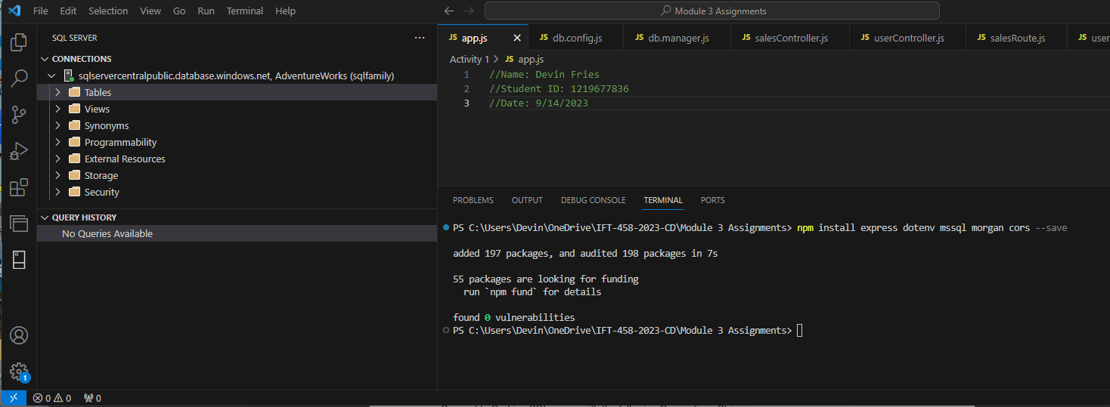

2. Task 2 Screenshot: 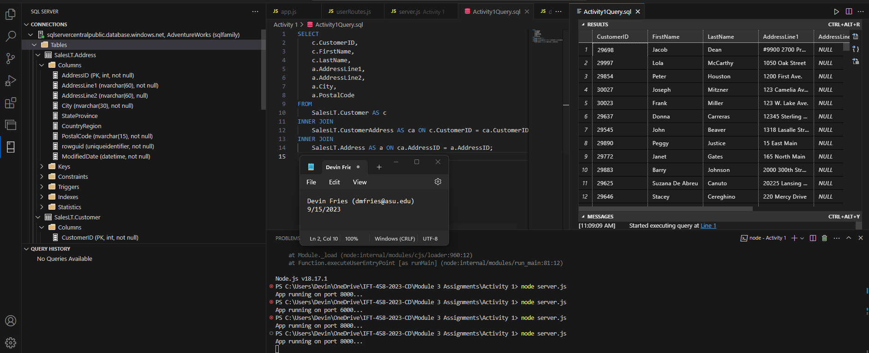

3. Task 3 Screenshot and code: (**on the next page!**) 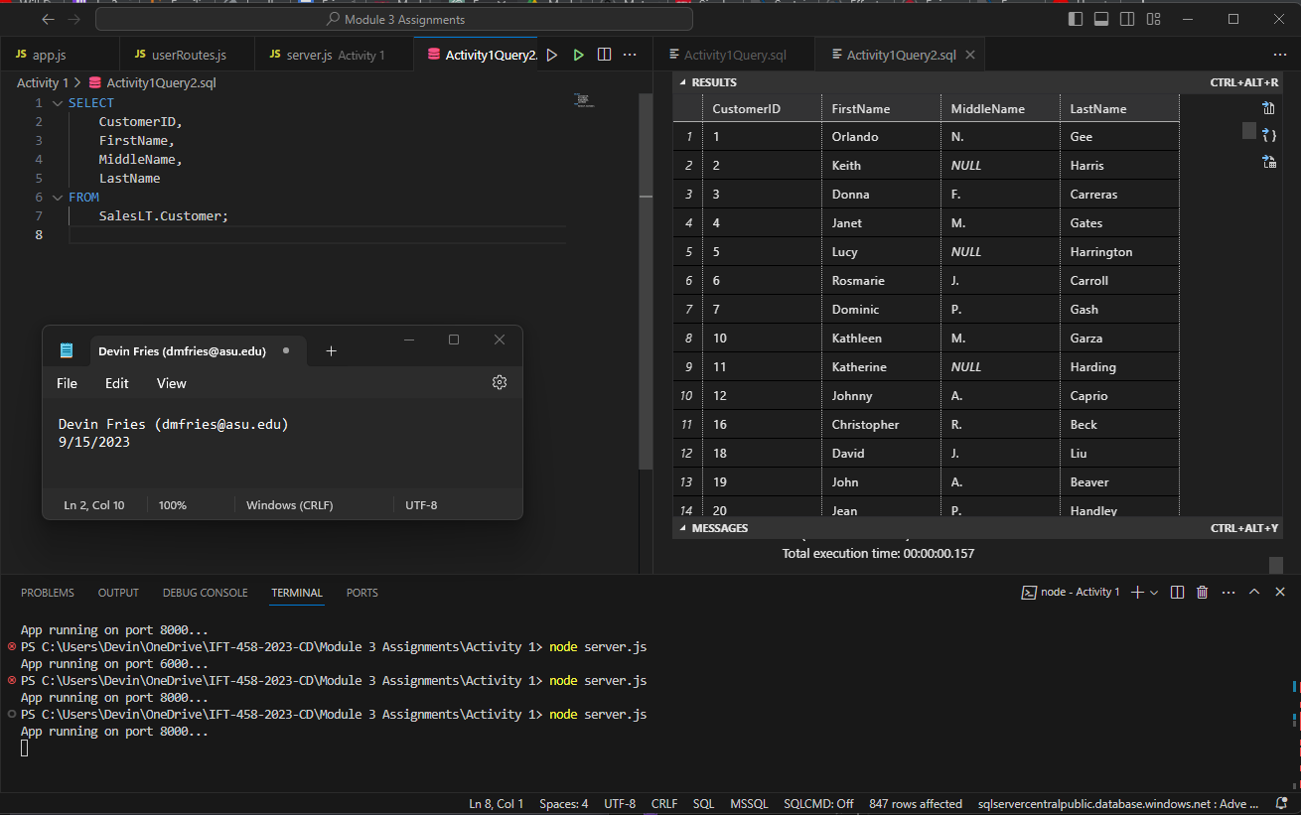

Code: SELECT

CustomerID,

FirstName,

MiddleName,

LastName

FROM

SalesLT.Customer;

4. Task 4 Screenshot and Code: (**on the next page!**)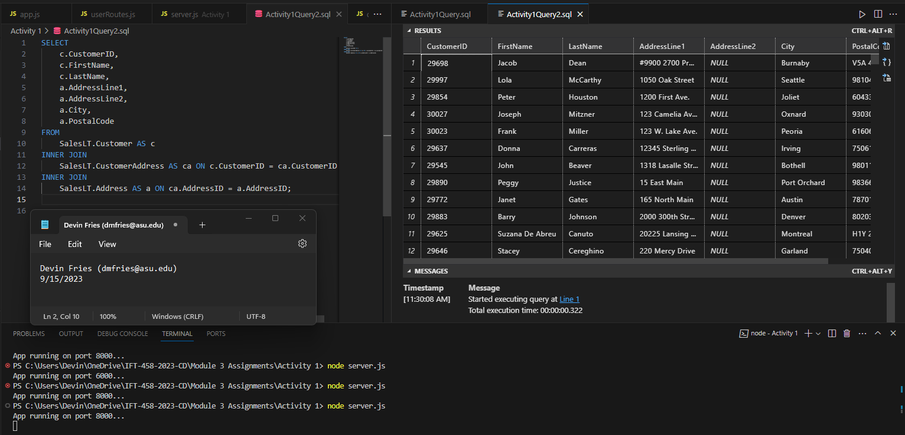

Code:

SELECT

c.CustomerID,

c.FirstName,

c.LastName,

a.AddressLine1,

a.AddressLine2,

a.City,

a.PostalCode

FROM

SalesLT.Customer AS c

INNER JOIN

SalesLT.CustomerAddress AS ca ON c.CustomerID = ca.CustomerID

INNER JOIN

SalesLT.Address AS a ON ca.AddressID = a.AddressID;